**Cover Page Notes**

* Center your title a third of the way down the page.
* For subtitles, end the title line with a colon and place the subtitle on the line below the title.
* Several lines later, place your name, course, and the date

[Title of Paper]

In support of MFA Thesis Exhibition, Spring [Year]

[Your Name]

Thesis Committee Members:

[Name], Mentor

[Name], Graduate Faculty

[Name], Outside Advisor

**Example Thesis: Put Title Here**

This thesis template is a three-part resource for MFA students at MCAD. It serves as a template for your own papers in that it is pre-formatted to adhere to the Chicago style guidelines, and you can simply replace the text here with your own content to feel confident that your paper is properly formatted. In addition, it provides you with an overview of the most common rules you will need to follow when writing a paper. Finally, it includes all of the required sections (noted by bold headings) in your thesis. This is not an exhaustive list of style and citation rules for Chicago Style. Please be sure to familiarize yourself with resources you can turn to for additional help (many of which are cited in the bibliography at the end of the template). And of course, you can also stop by or [email the Learning Center](mailto:learning_center@mcad.edu) for assistance.

Per the *Chicago Manual of Style* (CMS), papers should adhere to the following guidelines:

* Set margins at no less than 1” and no greater than 1.5” (preference is 1” all around)
* Use a readable, serif typeface, such as Times New Roman or Palatino. For MFA thesis papers, you may also opt to use Helvetica.
* Size font no less than 10 pt., but preferably 12 pt.
* Double-space all text, with the following exceptions:
  + Single space block quotations, table titles, and figure captions, and each individual note and bibliographic entry (place an extra line space between note and bibliographic entries)
* Block a prose quotation of five or more lines
  + Do not enclose a blocked quotation in quotation marks.
  + Place an extra line space immediately before and after a blocked quotation.
  + Indent entire blocked quotations 0.5”
* Begin page numbers in the header of the first page of text with Arabic numeral 1
* Do not include extra space between lines or paragraphs (in other words, set your paragraph spacing to “0” before and after).[1]
* Single space between sentences and after punctuation marks.
* Keep text flush with the left margin.
* Indent the first line of each paragraph 0.5”
* Indent second and subsequent lines of each bibliography entry (hanging indent) 0.5”
  + NOTE: do not use hard line breaks and the space bar to create paragraph indents or hanging indents
* Avoid underlining; use italics instead
* Use title case for chapters and other titles
* Use proper style for subheads
* Indent an entire block quote 0.5” (including poetry extracts – do not center)
* Utilize the footnote or endnote function in your Word Processor; do not manually insert these elements
* Use subheadings for longer papers.

**Headings and Subheadings**

Headings should follow a hierarchy of logic in your paper; organize your content beginning with the broadest sections under Level 1 headings. Move on to level 2 only if you are subdividing a level 1 section into two or more sub-sections, and so on. Typically, course papers will use only Level 1 headings while longer works, like theses or capstone papers, will incorporate Levels 2 and 3. Generally, levels 3, 4, and 5 are only needed for book-length manuscripts.

|  |  |
| --- | --- |
| **1** | **Centered, Boldface or Italic Type, Headline-style Capitalization** |
| 2 | Centered, Regular Type, Headline-style Capitalization |
| **3** | **Flush Left, Boldface or Italic Type, Headline-style Capitalization** |
| 4 | Flush left, roman type, sentence-style capitalization |
| **5** | **Run in at beginning of paragraph (no blank line after), boldface or italic type, sentence-style capitalization, terminal period.** Begin the paragraph immediately following the heading, like this. |

**Illustrations, Charts, and Tables**

Consecutively number illustrations, figures, and/or tables, and place illustration, figure, and table notes at the foot of the element (see figure 1). Always refer to illustrations, figures, and tables by number in your text (for example, “see Figure 1,” rather than by description of their placement, such as “see figure below.”). The titles and descriptions of figures, charts, and illustrations should appear after the number in the caption at the bottom of the element. If you need to cite the element, then add a footnote or endnote to the descriptions. Figures 1 and 2 demonstrate these rules.



**Figure 1.** Writing tutoring icon from the Learning Center’s Online Writing and Learning Lab (OWLL)

Unless grouping images or illustrations in a gallery at the end of a paper, the illustrations should be placed as close to their descriptive or referring text as possible and numbered consecutively with other figures (see figure 2).

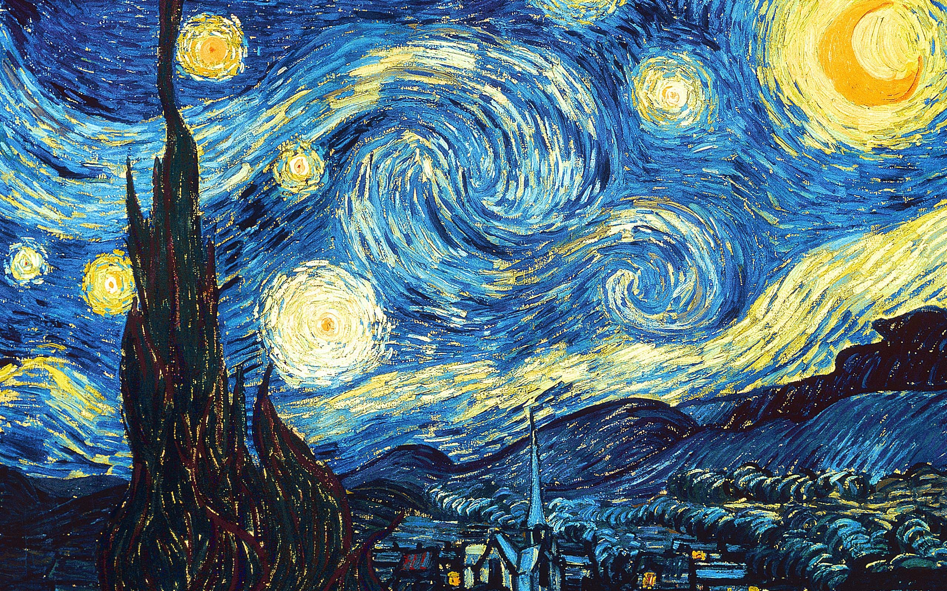

**Figure 2.***The Starry Nigh*t, by Vincent van Gogh, 1889[2]

A table should have no vertical rule lines and should use just three horizontal rule lines: one at the top of the table, between the table title and the column headings, one between the column headings and the first row, and one at the bottom of the table, just above the table caption (notes) if there is one (see table 1). Number tables separately from illustrations or other elements. Place the number and title above the table. Keep titles descriptive, yet brief.

**Table 1.** Tutoring by Type

|  |  |
| --- | --- |
| Tutor Type | Percent of Learning Center Visits |
| Writing | 47.4% |
| Software | 4.6% |
| Success Coach | 23.7% |
| Other | 24.3% |

Note: Data collected between January 1 and June 31, 2015

**Citation: Footnotes, Endnotes, and Bibliographies**

Footnotes

* Begin note numbers with “1” and continue consecutively throughout a single manuscript.
* Place the superscripted note number at the end of the clause or sentence to which it refers and after any punctuation.
* Within the note itself, the note number can be either full sized or superscripted. If full sized, it should be followed by a period. [3]
* Indent the first line of each footnote .5” from the left margin, but keep subsequent lines within a footnote flush left.
* Separate each footnote with an extra line space, but keep the footnotes themselves single spaced.
* After providing the long-form citation for a source, you can shorten subsequent citations of that same source. The basic structure of a shortened citation consists of the last name of the author and the main title of the work cited, which should be shortened if it is more than four words. [4]
* If you are citing several concepts or pieces of information from the same sources, use the abbreviation *Ibid* to indicate to the reader that the information is from the same source in the immediately preceding citation. *Ibid* takes the place of the aithor/editor and title of the work. However, if the information appears in a different page, then include the new page number. [5]
* If you need to add commentary to a footnote, place it after the citation/documentation. [6]
* If citing within a paragraph rather than in a footnote (a parenthetical citation), use a semicolon to separate documentation from commentary (Clements, Angeli, Schiller, Gooch, Pinkert, and Brizee, “General Format;” though I obtained this information from the Chicago Manual of Style website and the Purdue OWL, most all of this information is available on the various other websites).  **Note: use parenthetical citations sparingly; citation should come in the form of footnotes.**

Endnotes

Endnotes, as the name implies, appear at the end of a manuscript rather than in the footer of a page within the manuscript, as footnotes do. While footnotes are more convenient for readers, endnotes are useful when footnotes are lengthy and thus interfere with the layout of a page. Regardless of which you choose to use, you want to be sure to be consistent throughout the paper and to use your best judegment regarding what to place in your footnote or endnote. With footnotes, especially, readers can become frustrated if they have to move back and forth from the page they are reading to the end of the document to learn more about what you are discussing. If information is essential to your idea development, then include it in the body of your paper, not in a footnote or endnote. In the same vein of not annoying your reader, avoid the use of *Ibid* in endnotes as it will be less obvious to your reader what source you are citing.

Bibliographies

* Label your comprehensive list of sources with the heading “Bibliography.”
* Place two blank lines between the “Bibliography” heading and the first source entry.
* Place one blank line between entries, but single space each individual entry.
* Organize entries in alphabetical order according to the first word in each entry.
* Multi-author entries**:**
  + Use the word “and” before the final name (not &).
  + For two to three authors, write out all names.
  + For four to ten authors, write out all names in the bibliography but only the first author’s name plus “et al.” in notes and parenthetical citations.
  + If listing several sources by the same author, order them alphabetically by title and use 3-Em dash in place of the author name.
  + When a source has no identifiable author, cite it by its title, both on the references page and in shortened form (up to four keywords from that title) in parenthetical citations throughout the text.
* Write out publishers’ names in full.
* Do not use access dates unless publication dates are unavailable.
* If you cannot ascertain the publication date of a *printed*work, use the abbreviation “n.d.”
* Provide DOIs instead of URLs whenever possible.
* If you cannot name a specific page number when called for, you have other options: section (sec.), equation (eq.), volume (vol.), or note (n.).[7]

The basic formats for bibliographic entries follow.

**Article**

Article citations include: Full name of author or authors. Full title, including subtitle. Title of periodical. Issue information, including volume, issue number, date, etc. Page numbers. Publication information, including city, publisher, and date. DOI or URL if obtained online. (DOI is preferred).

In a note

Cecilia Menjivar, “Liminal Legality: Salvadorian and Guatamalan Immigrants’ Lives in the United States,” *American Journal of Sociology* 111, no. 4 (2006): 999-1037. doi:10.1086/499509.

In bibliography

Menjivar, Cecilia. “Liminal Legality: Salvadorian and Guatamalan Immigrants’ Lives in the United States.” *American Journal of Sociology* 111, no. 4 (2006): 999-1037. doi:10.1086/499509.

**Book**

Book citations include: Full name of author or authors. Full title, including subtitle. Editor, translator, or compiler, if applicable. Edition, if not the first. Volume if there is one. Series if there is one. Publication information, including city, publisher, and date. Page numbers if applicable. DOI or URL if obtained online.

In a note

Harvard H. Arnason, *History of Modern Art: Painting, Sculpture, Architecture, Photography*, 7th ed. (Boston: Pearson Education, Inc., 2013).

In bibliography

Arnason, H. Harvard. *History of Modern Art: Painting, Sculpture, Architecture, Photography*, 7th ed. Boston: Pearson Education, Inc., 2013.

**Video**

Video (most all audiovisual material) citations include all facts relevant to identifying the source, and will vary depending on the nature of the material. If information is obtained from a reproduced production, cite the production viewed, not the original.

In a note

*Joe Versus the Volcano*, directed by John Patrick Shanley (1990, Burbank, CA: Warner Home Video, 2002), DVD.

In bibliography

*Joe Versus the Volcano*. Directed by John Patrick Shanley. 1990. Burbank, CA: Warner Home Video, 2002. DVD.

**Website**

Website citations include: The title or description of the page. The author of the content if there is one. The owner or sponsor of the site. The URL. The date of publication or last updated or the access date.

In a note

“Service Bureau,” Minneapolis College of Art and Design, accessed August 5, 2015, http://www.intranet.mcad.edu/departments/service-bureau.

In bibliography

“Service Bureau.” Minneapolis College of Art and Design. Accessed August 5, 2015, http://www.intranet.mcad.edu/departments/service-bureau.

**Image**

Image citations include: The Artistʼs name. Title of the work. Date it created. Repository, museum, or owner (in other words, where it is now located). City or country of origin. Dimensions of the work. Material or medium (oil on canvas, marble, found objects, etc.). If you found the image in a book, you will also need to cite the book. If you found the image online, you will need to cite the website.

In a note

Vincent van Gogh, *The Starry Nigh*t, 1889, oil on canvas, 29 in. x 36 ¼ in.,  
Museum of Modern Art, New York.

In Bibliography

Gogh, Vincent van. *The Starry Night*. 1889. Oil on canvas. 29 in. x 36 ¼ in. Museum of Modern Art, New York.

**Conclusion**

If you need any additional help, please contact the Learning Center by [making an appointment](https://youtu.be/rN9UsAiOwI0) or [sending us an email](mailto:learning_center@mcad.edu)!

**Bibliography**

Arnason, H. Harvard. *History of Modern Art: Painting, Sculpture, Architecture, Photography*, 7th ed. Boston: Pearson Education, Inc., 2013.

Clements, Jessica, Elizabeth Angeli, Karen Schiller, S. C. Gooch, Laurie Pinkert, and Allen Brizee. “General Format.” *The Purdue OWL*. October 12, 2011. http://owl.english.purdue.edu/owl/resource/717/13/.

Gogh, Vincent van. *The Starry Night*. 1889. Oil on canvas. 29 in. x 36 ¼ in. Museum of Modern Art, New York.

*Joe Versus the Volcano*. Directed by John Patrick Shanley. 1990. Burbank, CA: Warner Home Video, 2002. DVD.

Menjivar, Cecilia. “Liminal Legality: Salvadorian and Guatamalan Immigrants’ Lives in the United States.” *American Journal of Sociology* 111, no. 4 (2006): 999-1037. doi:10.1086/499509.

“Service Bureau.” Minneapolis College of Art and Design. Accessed August 5, 2015, http://www.intranet.mcad.edu/departments/service-bureau.

University of Chicago Press. *The Chicago Manual of Style*. 16th ed. Chicago: University of Chicago Press, 2010.

**Additional Resources for Learning Chicago Style**

Steiner-Williams, Judy. “Using the Chicago Manual of Style.” Accessed August 19, 2015, http://www.lynda.com/Education-Student-Tools-tutorials/Using-Chicago-Manual-Style/158319/183921-4.html.

University of Chicago Press. *The Chicago Manual of Style Online*. University of Chicago Press. 2010. Accessed August 19, 2015, http://www.chicagomanualofstyle.org/

**Work Sample Identification List**

1. List should be numbered and should include thumbnails
2. Each list item should include number, title of work, medium or media, year of completion, dimensions, brief description

Next Steps:

* Save as a PDF, then as PDF/A 1-b in next step
* Open file in Adobe Acrobat
  + File Naming Convention (continued on next page)
  + File Naming Convention (continued)
    - <first initial last name_thesis_year of graduation.pdf>
    - Example: tdebiaso_thesis_2015.pdf
  + Final Steps for Preparing PDF,
    - Look at Properties for embedded fonts, confirm no errors
    - Save as **PDF/A 1-b**

1. University of Chicago Press, *The Chicago Manual of Style, 16th ed.* (Chicago: The University of Chicago Press, 2010). For instructions on setting your spacing, click [here](http://screencast.com/t/UhBBb5t7gFu5).
2. Vincent van Gogh, *The Starry Nigh*t, 1889, oil on canvas, 29 in. x 36 ¼ in., Museum of Modern Art, New York.
3. Jessica Clements et al. “General Format,” *The Purdue OWL*, October 12, 2011, http://owl.english.purdue.edu/owl/resource/717/13/.
4. *Chicago Manual of Style.*
5. Ibid., 669.
6. Clements et al. “General Format.” 
7. Ibid.